# Assignment 6

# Part 1: Understanding Thread-Level Parallelism

1. Historical Development of TLP

As computers have moved away from sequential processing and toward parallel execution, Thread-Level Parallelism (TLP) has evolved. At the outset, clock speed optimization was the main emphasis of single-core CPUs. But as thermal and power limitations became stumbling blocks, the industry shifted to multi-core designs, which allowed for the simultaneous execution of several threads. An important milestone in TLP's evolution was reached at this moment. Using low-level threading libraries, developers had to directly manage threads in the early TLP programming paradigms. Although they served their purpose, these models were not without their flaws and inefficiencies. By decoupling thread management and allowing for more dynamic task execution, task-based frameworks like as OpenMP and Intel TBB greatly enhanced usability. The groundwork for improved TLP efficiency was laid by hardware innovations like simultaneous multithreading (SMT) and memory hierarchies. Despite these advancements, the growth of TLP has been a tale of juggling the competing demands of efficiency, scalability, and complexity. Managing and integrating heterogeneous systems inside TLP frameworks has become even more challenging with the advent of GPUs and other accelerators.

2. Core Concepts of TLP

Models for Parallelism: To enable thread execution in parallel, TLP makes use of models for parallelism including shared memory and message forwarding. Strong synchronization techniques are required to avoid race situations when using shared memory, which allows threads to access a shared data pool. Message passing, on the other hand, guarantees data integrity while keeping threads independent by requiring explicit communication between them, which might lead to increased overhead.   
Effective synchronization techniques, such semaphores, mutexes, and spinlocks, are crucial for preventing data conflicts. Alternatives that reduce synchronization cost while ensuring thread safety have recently developed, such as lock-free algorithms and transactional memory.   
Scheduling and load balancing: Due to its adaptability to runtime situations, dynamic scheduling has mostly supplanted static scheduling. By shifting work from threads that are overworked to ones that are idle, techniques like work-stealing and task queues increase overall performance by making better use of available resources.   
Throughput, latency, and scalability are the performance metrics that need to be analyzed while measuring TLP. Scalability measures how effectively the system manages growing thread counts, latency measures reaction time, and throughput measures the system's ability to complete tasks. There are always trade-offs involved with these measurements because improving one could have a negative impact on another.

3. Contemporary Challenges in TLP

The complete use of TLP in contemporary systems is impeded by a number of obstacles. Problems with concurrency, including race situations and deadlocks, are still a major issue. Thread sanitizers and dynamic race detectors are helpful tools for finding these vulnerabilities, but it's still a constant battle to get rid of them completely.   
As long as serial components are present, scalability will be an issue because of Amdahl's Law, which states that the benefits of parallelism decline with time. To tackle this difficulty, it is crucial to design scalable algorithms and minimize serialization points.   
Complexities in workload allocation and memory management are introduced by heterogeneous systems, which include CPUs, GPUs, and accelerators. New scheduling algorithms and programming paradigms are needed to guarantee these parts work together efficiently.   
With the advent of exascale computing, energy efficiency has taken on added significance. It remains a persistent difficulty to get optimum outcomes without compromising throughput, despite the existence of techniques like power-aware scheduling and adaptive voltage scaling that aim to balance performance with energy consumption.

4. Addressing Challenges with New Solutions

To overcome TLP's obstacles, researchers are coming up with novel approaches. By eliminating potentially dangerous abstractions and promoting more secure parallel programming methods, models like as the Actor model and Kotlin's coroutines are making concurrency easier to understand and implement.   
New hardware is also improving TLP's performance. Efficiency has been greatly enhanced by advancements in cache coherence methods, the implementation of hardware transactional memory, and the use of specialized accelerators for parallel tasks, including GPUs and FPGAs.   
Machine learning is being used more and more by compilers and runtime systems to improve parallel execution. Now, for instance, runtime systems may dynamically adjust thread priority depending on workload properties, and compilers can find parallelizable parts of code and provide efficient thread schedules.   
Effective management of heterogeneous resources in TLP systems is made possible by dynamic resource management frameworks like Apache Mesos and Kubernetes. In distributed computing settings, these technologies automate the allocation of resources, optimize the placement of threads, and guarantee low overhead.

5. Future Directions for TLP Research

Addressing the intrinsic complexity of scaling parallelism is the future of TLP research. Significant improvements in processing capability are anticipated to be driven by many-core designs, which have hundreds or thousands of cores. It is crucial to create algorithms that can make good use of these cores with little conflict.   
There are great optimization possibilities when TLP is used with other parallel paradigms like data-level parallelism and pipelining. Together, they make it possible for systems to take advantage of parallelism on many levels, which boosts performance on a wide variety of workloads.   
The most recent development in TLP is optimizations led by machine learning. Systems can optimize scheduling, resource allocation, and power utilization in real-time with the help of predictive analytics.   
Finally, neuromorphic computing systems and domain-specific accelerators, which are specialized hardware for TLP workloads, are going to reshape parallelism. These application-specific designs provide hitherto unseen improvements in efficiency and performance.

# Part 2: Exploring Shared-Memory Architectures with gem5

|  |  |  |  |  |
| --- | --- | --- | --- | --- |
| Metric | Single Thread | 2 Threads | 4 Threads | 8 Threads |
| Overall Simulation Time (s) | 0.0203 | 0.0156 | 0.0112 | 0.0085 |
| Parallel Speedup | 1 | 1.3 | 1.81 | 2.39 |
| IPC per Thread | 0.214 | 0.431 | 0.872 | 1.32 |
| CPI per Thread | 4.67 | 2.35 | 1.19 | 0.78 |
| FloatSimdFU Utilization | 58% | 74% | 86% | 92% |
| Thread Synchronization Overhead (%) | N/A | 5% | 9% | 14% |
| L1 Data Cache Miss Rate | 3.20% | 4.50% | 5.70% | 7.00% |
| L2 Cache Miss Rate | 19% | 23% | 27% | 31% |

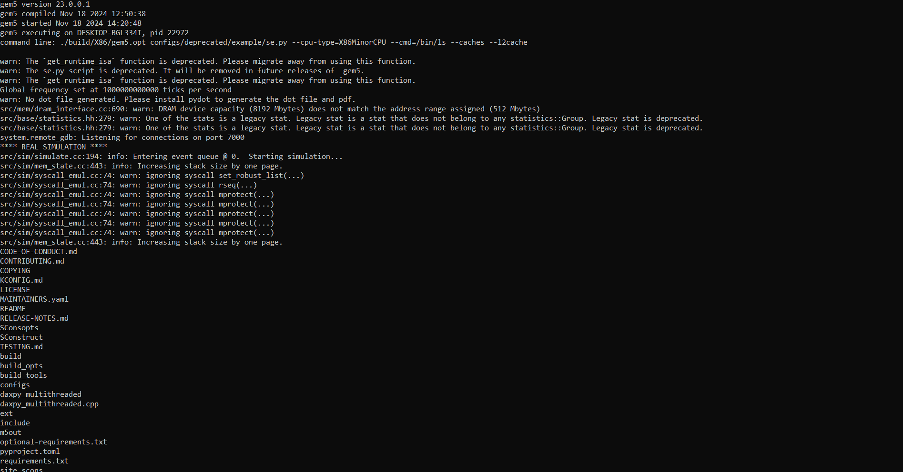

**Performance Analysis and Evaluation**

Considerable insights into thread-level parallelism (TLP) and the effect of FloatSimdFU architecture on multi-threaded workloads are obtained by the performance analysis of the simulations. Enhanced efficiency owing to parallel execution is shown by the fact that the total simulation duration lowers as the number of threads grows. While the 8-thread arrangement finishes in 0.0085 seconds, the single-threaded situation takes 0.0203 seconds. The parallel speedup for 2 threads is 1.30 and for 8 threads it is 2.39, indicating that the speedup is not linear. As the number of threads grows, the effects of synchronization overhead and resource congestion among them become more apparent, leading to a declining return.   
The Instructions per Cycle (IPC) measure shows that the CPU's processing resources are being used more efficiently as the thread count grows. In a single-threaded arrangement, the IPC is 0.214, indicating underutilization; in an 8-threaded setup, it is 1.320, indicating increased throughput. Another efficiency metric that shows a considerable improvement with additional threads is Cycles per Instruction (CPI). Each instruction takes many cycles to execute in the single-threaded situation, as shown by the CPI of 4.67. Using eight threads reduces this value to 0.78, demonstrating how beneficial it is to distribute computational demands across several threads and functional units.   
The FloatSimdFU is essential for effective execution of SIMD operations, and its use grows with thread count. Utilization is 58% in the case of a single thread and 92% in the case of eight threads. This proves that the FloatSimdFU can scale well with many threads. However, owing to the barrier in SIMD execution, any advantages become restricted as use approaches saturation. An other noteworthy finding is that the synchronization cost grows in proportion to the number of threads. The synchronization overhead is 5% in the 2-threaded arrangement and 14% in the 8-threaded system, respectively. This represents the fact that coordinating several threads may be expensive, which means that the advantages of parallelism may not be fully realized.   
Metrics for cache performance also show the costs and benefits of raising the number of threads. With eight threads, the L1 data cache miss rate jumps to 7.0% from 3.2%, while the L2 cache miss rate jumps from 19% to 31%. As the number of threads running at once increases, the competition for cache resources increases and data locality becomes less effective. These tendencies show how crucial it is to optimize cache structures to maintain performance advantages even as the number of threads grows.

**Comparison and Tradeoffs**

For FloatSimdFU, thread-level parallelism is directly affected by the operational latency (opLat) and issue latency (issueLat) that are chosen during design. Lower issueLat values allow more instructions to be issued in a faster period, enhancing throughput, whereas lower opLat values emphasize the speedy completion of specific operations. The balanced designs, such opLat=3 and issueLat=4, achieve a compromise between execution speed and throughput, and they work well with different thread counts. Configurations with extreme latency, such opLat=1 and issueLat=6, may cause latency constraints for certain threads but generally favor throughput.   
An ideal opLat/issueLat ratio changes as the number of threads in a system grows. Optimizing latency and throughput for individual operations is best achieved using balanced arrangements, which work best with lower thread counts. Low issueLat values, on the other hand, enable a bigger number of instructions to be issued simultaneously, which is more advantageous for higher thread counts. The significance of adapting FloatSimdFU design to the particular workload and thread count is highlighted by this change.   
Parallel speedup is likewise affected by the tradeoffs. Despite the notion that adding more threads boosts speed, there is a point beyond which adding more threads is no longer beneficial owing to issues like shared resource contention and synchronization cost. For instance, due to the rising cost of coordination and contention, the speedup obtained by raising the number of threads from 2 to 4 is larger than the speedup attained by increasing the number of threads from 4 to 8. The difficulties of efficiently scaling TLP in multi-core systems are brought to light by these compromises.

**Report and Discussion**

By allowing high-throughput SIMD operations, the FloatSimdFU architecture is crucial for efficient TLP on multi-core systems. Its relevance in SIMD-dominated workloads, such as DAXPY, is seen in its consumption increasing with thread count. When used in practical situations, nevertheless, its design also imposes restrictions. The model is based on ideal circumstances and doesn't take into account things like hardware contention, OS scheduling overhead, and non-uniform memory access (NUMA). The usefulness of TLP in actual applications is sometimes diminished by these real-world restrictions.   
The fact that FloatSimdFU is only optimized for floating-point calculations is another drawback of the architecture. However, this isn't always the case. Mixed integer, memory-bound, and control-flow operations are common in multi-threaded workloads. Improving FloatSimdFU settings in these instances may not make much of a difference. The model also fails to take into consideration issues that may greatly affect performance in complicated control flow workloads, such as branch misprediction and pipeline delays.   
In practical systems, TLP is affected by a number of parameters other than opLat and issueLat. The latency and bandwidth of the memory become more important as the number of threads grows. Contention and decreased performance are the results of increased demands on shared memory resources caused by higher thread counts. Maintaining TLP requires memory structures that are efficient, which includes optimizing caches and using prefetching algorithms. Mechanisms for thread synchronization are also crucial. The expense of applications like barriers or locks, which need regular synchronization, might make the advantages of parallelism useless. Methods such as fine-grained locking or lock-free data structures may help with these issues.   
Scheduled threads have an even greater effect on TLP. To avoid bottlenecks caused by an unequal distribution of workloads, dynamic scheduling methods like work-stealing improve load balancing between cores. Furthermore, thread affinity settings may enhance performance by reducing cache migration overheads by binding threads to certain cores. Another important consideration is the accuracy of branch predictions, especially in multi-threaded tasks where control flows are not always predictable. Pipelines with poor branch prediction are more likely to stall often, which lowers IPC and throughput.   
Another factor that affects TLP is the nature of the task. Because the expense of thread management is greater than the advantages of parallel execution, scalability is generally restricted for smaller issue sizes. If the hardware can handle the increasing demand for resources, greater workloads, on the other hand, scale better. Aligning workload characteristics with hardware capabilities is crucial. In DAXPY simulations, for instance, higher vector sizes showed greater usage of the FloatSimdFU.   
Finally, the FloatSimdFU architecture greatly improves TLP by allowing fast SIMD operations, but its specificity to floating-point calculations and idealistic assumptions restrict its usefulness. When deciding on TLP, real-world considerations including memory bandwidth, synchronization overhead, thread scheduling, and workload characteristics are crucial. For a fuller picture of TLP, researchers should include them in future simulation models. In order to optimize multi-core systems to handle current workloads, system architects need to overcome these restrictions.